**C868 – Software Capstone Project Summary**

**Task 2 – Section C**

|  |  |
| --- | --- |
| **Capstone Proposal Project Name:** | http://www.idevnews.com/views/images/uploads/general/wgu_logo.png  PCB Component Planner |
| **Student Name:** | Nathaniel Unruh |

**Table of Conents**

Contents

Table of Conents 2

Application Design and Testing 3

Design Document 3

Class Design 3

UI Design 3

Unit Test Plan 5

Introduction 5

Purpose 5

Overview 5

Test Plan 5

Items 5

Features 5

Deliverables 5

Tasks 6

Needs 6

Pass/Fail Criteria 6

C4. Source Code 6

User Guide 7

Introduction 7

Installation and Using the Application 7

# Application Design and Testing

# Design Document

## Class Design

The following class design diagrams depict the class “ReportFormController” which is the logic behind the Report Form screen, and the “LoggingHandler” class which handles writing the report to a text document.

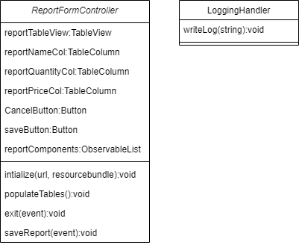

## UI Design

The following are the UI Designs for the Main screen of the program and the Report screen from the program. The Main screen (Figure 1) was designed with simplicity and ease of use in mind. The Report screen (Figure 2) was created to be easy to read and to save to a text document if the user would like a saved report.

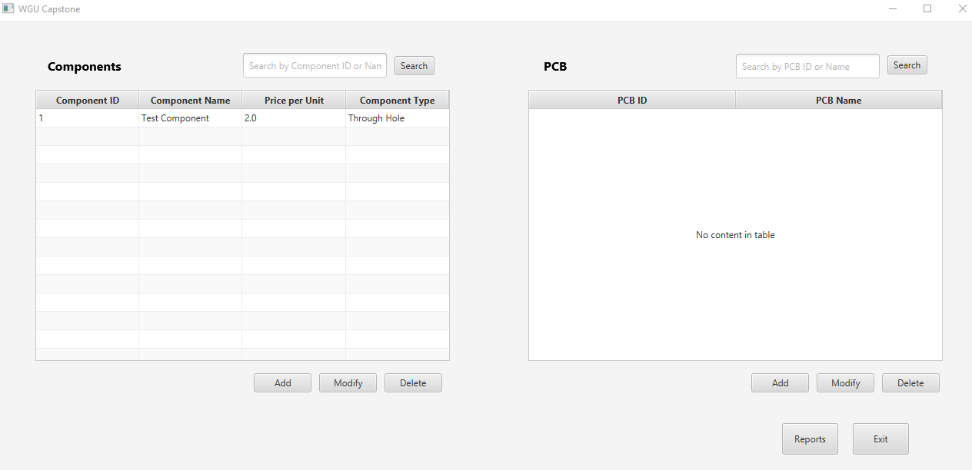

Figure 1, Main screen

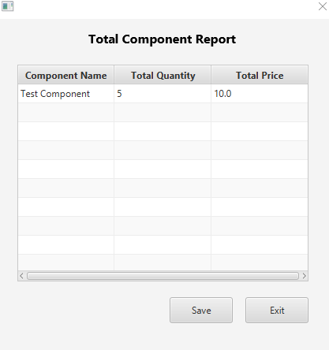

Figure 2, Report screen

# Unit Test Plan

## Introduction

### Purpose

The testing methods for this program will be to test functionality through the UI of the program. The development team will test that all functions are working at each stage of the development. During development there were no issues or defects found.

### Overview

The tests conducted by the development team were through the program’s UI during development. During each stage of development each part of the functionality was tested 10 times to ensure no errors or defects. This method was used throughout the entire program.

## Test Plan

### Items

The requirements for this test are to try each function 10 times.

### Features

* Log in screen
* Main screen search functions
* Add, modify, remove for both Component and PCB
* Report function
* Exit function

### Deliverables

The deliverables for these tests would be the program functioning without crashing or returning any errors.

### Tasks

* Log in screen

Attempt to log in using a known good username/password

* Main screen search functions

Use the search boxes to make sure the Components and PCB are properly filtered.

* Add, modify, remove for both Component and PCB

Use each button to make sure the appropriate screen is opened, or function is executed.

* Report function

Use the report button and check that the report is accurate.

* Exit function

Use the exit button and check the program closes properly with no errors or memory leaks.

### Needs

The needs for this test include the user being on Windows 10, the program is installed on their machine, and that there is a connection to the MySQL database.

### Pass/Fail Criteria

The passing criteria for this test are that each function is completed without errors or defects 10 times. If the test passes development moves on to the next part of the development. If it fails, the issue is to be fixed and process repeated.

# C4. Source Code

The source code is included as a zip file with this submission.

# User Guide

*Note: This may be included as a separate document if you desire.*

## Introduction

This user guide will start by showing how to install the program, log in, and use the included features. The features shown will be how to add, modify, and remove both Components and PCB, followed by how to run, and save a report.

## Installation and Using the Application

1. To install the program, unzip the included PCB Component Planner.zip file, after unzipping open the folder.
2. Once in the folder you unzipped, you will see multiple files. To start the program double clicked on StartProgram (Figure 3, Program folder)

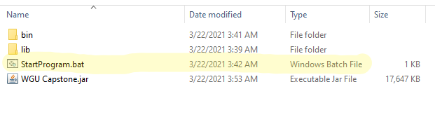

Figure 3, Program folder

3. The program will now open to the login page (Figure 4, Login screen). Here you will enter in your user credentials. User accounts can be added to the database for each employee, for testing we have been using the Username: “Test” and password: “Test”. Once you’ve entered the credentials, press login.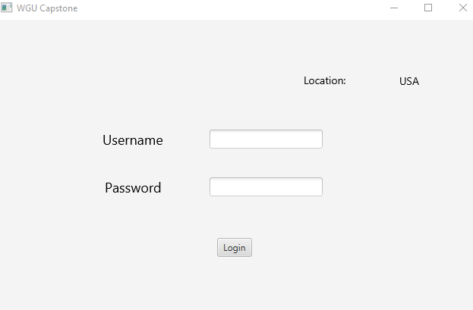

Figure 4, Login screen

4. You will now come to the main screen. On this screen you will see two tables which you can use search functions to search for components or PCB (Printed Circuit Board), you can add, modify and delete components and PCB. Next let’s click on the Add button just below the Components table. This will open the Component screen (Figure 5, Component screen).

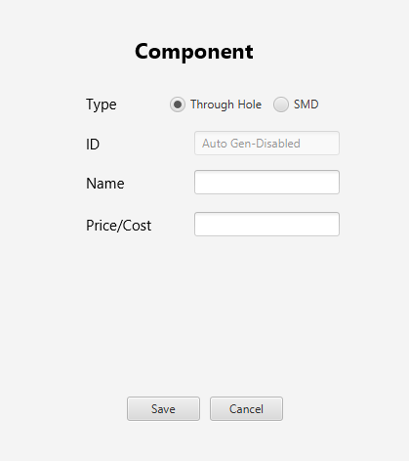

Figure 5, Component screen

5. On the Component screen, you will choose if it is a through-hole or SMD, input a name for the component, and input the price. Once you have completed the fields, press the Save button or if you do not want to save press cancel.

6. Back on the main screen, if you need to modify a component click its entry on the table and hit the Modify button, this will open the Component screen (Figure 3) and allow you to modify the entries.

7. If you want to delete a component, choose the component from the table and hit the Delete button just below the component table.

8. To add a new PCB click the Add button just below the PCB table on the right, this will open the PCB screen (Figure 6, PCB screen).

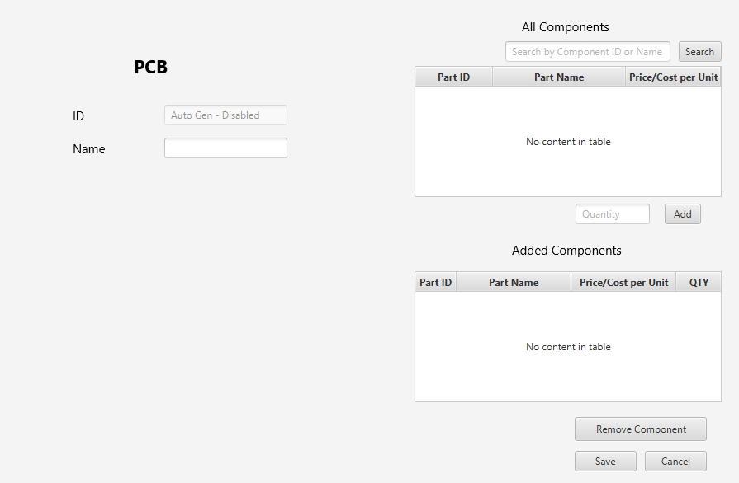

Figure 6, PCB screen

9. On the PCB screen you will need to enter a name for the PCB. On the right side there will be a list of all components available currently. To add a component, choose one from the All-Components table, input a quantity into the quantity box and hit the Add button. This will add the selected component to the bottom Added Components table. If you wish to remove a component, select it in the Added Components table and hit the Remove Component button on the bottom right. Now to save just hit the Save button, or if you do not want to save this PCB hit the Cancel button.

10. Back from the main screen, you will see a Reports button in the bottom right. To run a Report of the quantity of components used by all PCB and the total cost of them added together click the Reports button. This will open the Reports screen (Figure 7, Report screen) which will display the results. If you wish to save the results with a Date Time stamp to a text document labeled “Results.txt” in the program directory, hit Save otherwise you can exit without saving by hitting Exit.



Figure 7, Report screen

11. Once you are finished with the program hit the Exit button on the bottom right corner and the program will close.